Comment coder un scanner NFC

Il faut ajouter le permis NFC dans le code de l’application. 

Parse data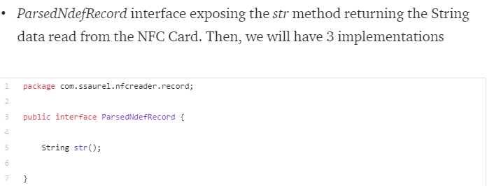

One for UriRecord implementing the str method and offering an isUri method letting you to know if data read from a NFC Card or Tag can be considered as an URI.

https://medium.com/@ssaurel/create-a-nfc-reader-application-for-android-74cf24f38a6f